Linux: It’s not just a hobby, it’s a career


Linux Systems and Network Admin. - $100,000/yr
Unix Administrator - $110,000/yr
Linux Systems Administrator
Systems Administrator - $60,000/yr

Median Salary by Job - Skill: Linux (United States)
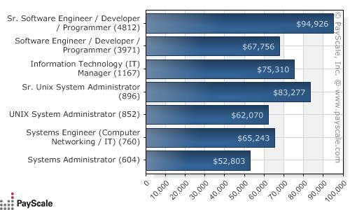

 job listing from Career Builder, Monster and payscale.com

