The Peter D. Cunneen Memorial
Golf Classic
Monday, August 8, 2011

BRIDGE SOLICITOR

___________________
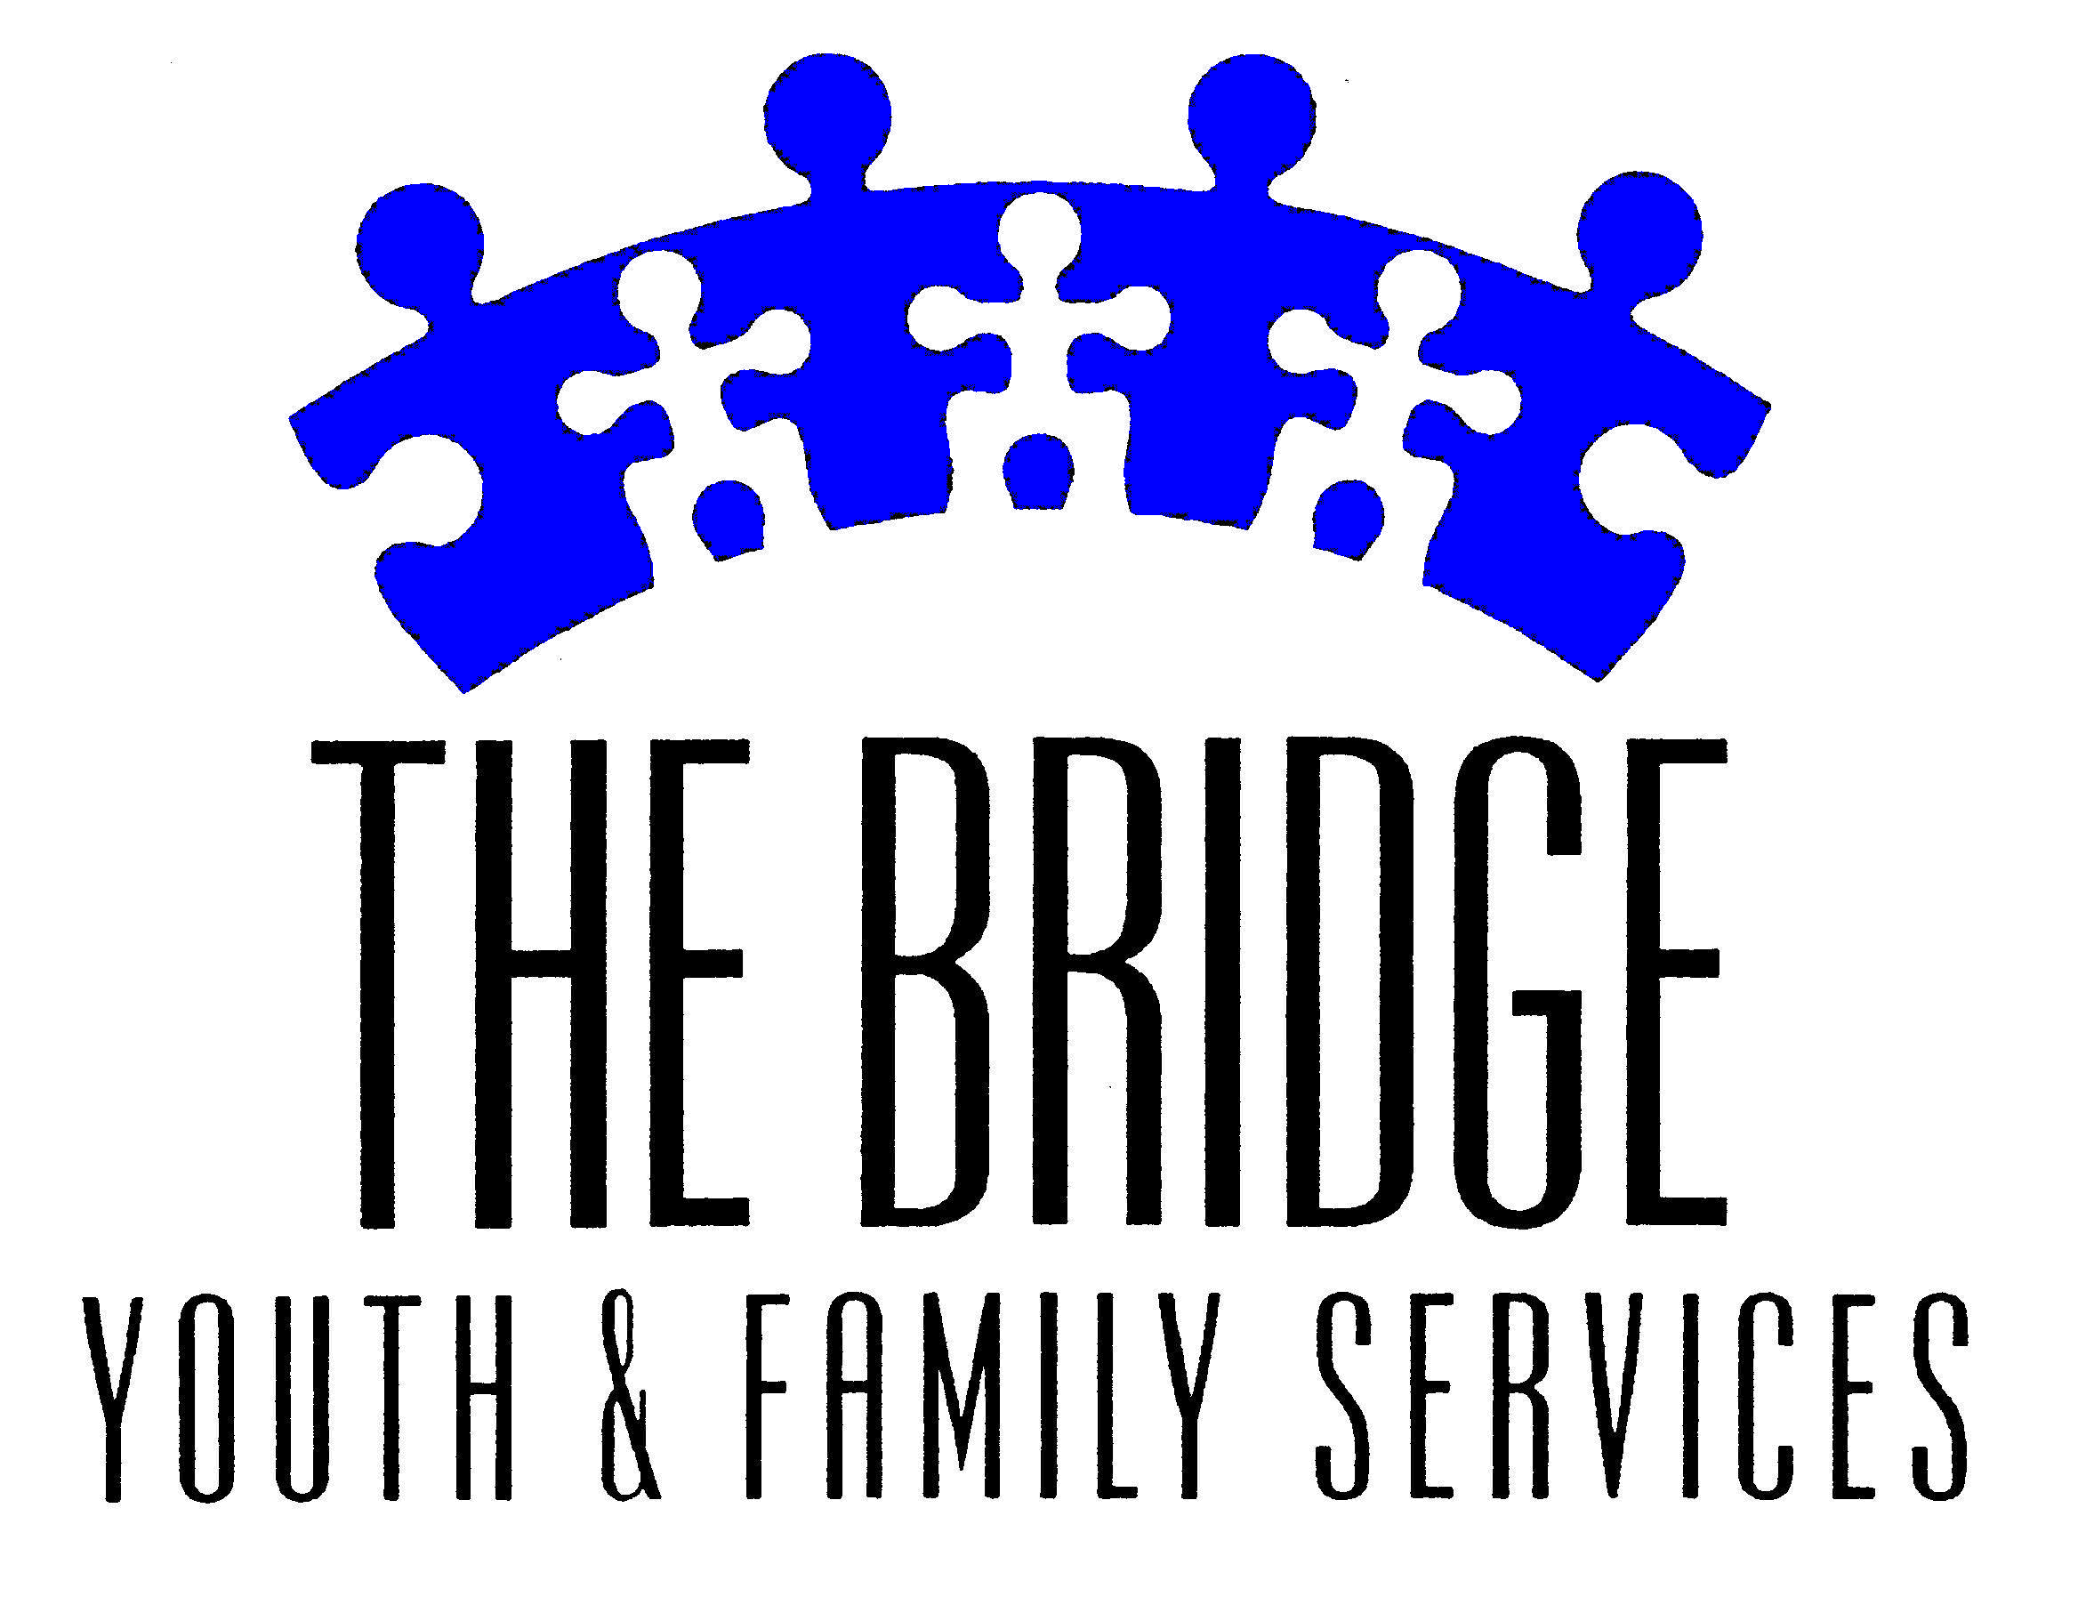

STAFF USE ONLY:
- Logged in
- Category:
- Item #:
Donor Agreement Form

donation Information
 For Auction/raffle Item or Service: ___________________________________________________________________________________
 For Gift Bags 125 items: ___________________________________________________________________________________
Retail Value: ___________ Please include interesting facts, unusual aspects, size, color, dates, etc..
Description: __________________________________________________________________________________________________
__________________________________________________________________________________________________________________________________________________________________________________________________________
Restrictions/Instructions: All buyers will have until August 8, 2012 to claim auction/raffle goods unless otherwise noted.
_____________________________________________________________________________________________________

Delivery Information Display Information
Delivery/Pick-Up Instructions Please supply by August 1, 2011.
 Item Enclosed  Menus, brochures, photos, etc.
 Donor will ship or deliver  Electronic delivery accepted
 Contact Donor to Arrange Pickup  TIF  EPS  JPEG  PDF

Donor Information
Donor name as it is to appear in Program Book: ________________________________________________
 Donor wishes to be ANONYMOUS
Name:______________________________________________________________________________
Company:____________________________________________________________________________
Street Address: _______________________________________________________________________
City, State, Zip: ________________________________________________________________________
Phone – Day:_________________________________ Phone – Evening: _________________________
Email Address: ________________________________________________________________________
Donor Signature: _______________________________________________________________________________

The Bridge is 501(c) (3) organization promoting the behavioral and emotional health of children and families throughout Northwest Suburban Cook County. Contributions to The Bridge are tax deductible for income tax purposes to the fullest extent allowed by law.

Please return the form to The Bridge Youth & Family Services: 721 S. Quentin, Palatine, IL 60067.
Tel: 847-485-3087; Fax: 847-359-7525; Email: cmchaley@bridgeyouth.org
All donations must be received by August 1, 2011, to be included in the auction book.

THANK YOU FOR YOUR DONATION!

