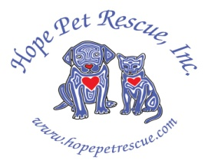  HOPE PET RESCUE, Inc.  CORDIALLY INVITES YOU AND YOUR FRIENDS TO OUR SECOND ANNUAL FUR BOWL-A-THON FUNDRAISER EVENT!!!  PINSTRIPES, 100 W. HIGGINS RD., SOUTH BARRINGTON, Il  WHEN: FRIDAY, NOVEMBER 4, 2011  TIME: 6:00PM – 10:30PM  THE REGISTRATION FEE OF $60 FOR ADULTS  INCLUDES THE FOLLOWING:  PASSED HORS D'OEUVRES DURING SILENT AUCTION,  A 5 COURSE FULL DINNER INCLUDING DESSERT AND DRINK TICKET PLUS 2 HRS. UNLIMITED BOWLING/BOCCE !  THERE WILL ALSO BE A BAKE SALE , 50/50 RAFFLE PRIZE, AND ENTERTAINMENT FOR THE KIDS – FACE PAINTING AND BALLOON ANIMALS! TICKETS FOR CHILDREN $20 AGES 5-12  IT WILL BE A GREAT TIME FOR ANIMAL LOVERS, BOWLING AFICIONADOS, OR JUST A FUN NIGHT OUT FOR A GREAT CAUSE!!  To purchase your tickets, view our silent auction items, or more information, please visit our website at: hopepetrescue.com  call 847-778-4349, or email info@hopepetrescue.com.  Hope Pet Rescue is a not-for profit 501 (c)(3) organization run and funded entirely by volunteers and generous donors like you. All donations are tax deductible. | 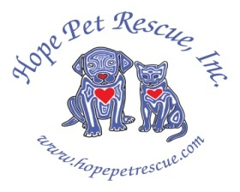  HOPE PET RESCUE, Inc.  CORDIALLY INVITES YOU AND YOUR FRIENDS TO OUR SECOND ANNUAL FUR BOWL-A-THON FUNDRAISER EVENT!!!  PINSTRIPES, 100 W. HIGGINS RD., SOUTH BARRINGTON, Il  WHEN: FRIDAY, NOVEMBER 4, 2011  TIME: 6:00PM – 10:30PM  THE REGISTRATION FEE OF $60 FOR ADULTS  INCLUDES THE FOLLOWING:  PASSED HORS D'OEUVRES DURING SILENT AUCTION,  A 5 COURSE FULL DINNER INCLUDING DESSERT AND DRINK TICKET PLUS 2 HRS. UNLIMITED BOWLING/BOCCE !  THERE WILL ALSO BE A BAKE SALE , 50/50 RAFFLE PRIZE, AND ENTERTAINMENT FOR THE KIDS – FACE PAINTING AND BALLOON ANIMALS! TICKETS FOR CHILDREN $20 AGES 5-12  IT WILL BE A GREAT TIME FOR ANIMAL LOVERS, BOWLING AFICIONADOS, OR JUST A FUN NIGHT OUT FOR A GREAT CAUSE!!  To purchase your tickets, view our silent auction items, or more information, please visit our website at: hopepetrescue.com  call 847-778-4349, or email info@hopepetrescue.com.  Hope Pet Rescue is a not-for profit 501 (c)(3) organization run and funded entirely by volunteers and generous donors like you. All donations are tax deductible.

