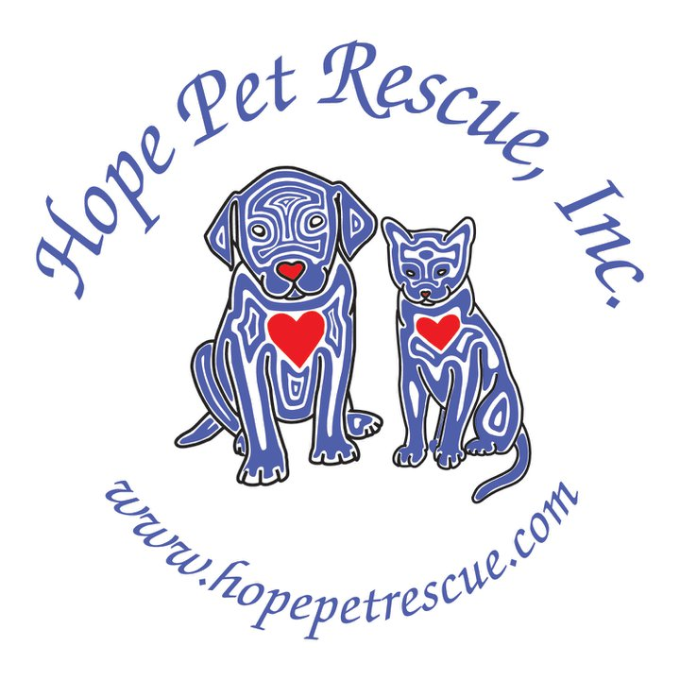
August 10, 2011
Hope Pet Rescue, Inc.
P. O. Box 32
Barrington, IL 60011

Re: Sponsor/Donation Request

To Whom It May Concern:

Hope Pet Rescue, Inc. is a licensed, 501 (c)(3) not for profit organization. Our mission is to save the lives of innocent animals in high-kill Illinois shelters who would otherwise be euthanized. They are then placed in foster homes until they are adopted to their permanent, new homes. We will be holding our 2nd annual Fur Bowlathon on Friday, November 4, 2011 at Pinstripes in South Barrington.

We are kindly seeking sponsors and requesting donations from businesses in the community. We are entirely funded and run by volunteers and generous donors such as yourself.

Contributions made to Hope Pet Rescue, Inc. are tax-deductible. The Rescue is an animal welfare organization with tax exempt 501 (c)(3) status. Our Federal Tax ID # is 27-3557972. No goods or services were offered in exchange for your generous gift.

Thank you for your support of shelter animals and the local community and we look forward to saving lives together.

Sincerely,

Leana Ruiz
Executive Director
Hope Pet Rescue, Inc.
lruiz@hopepetrescue.com
847-778-4349

