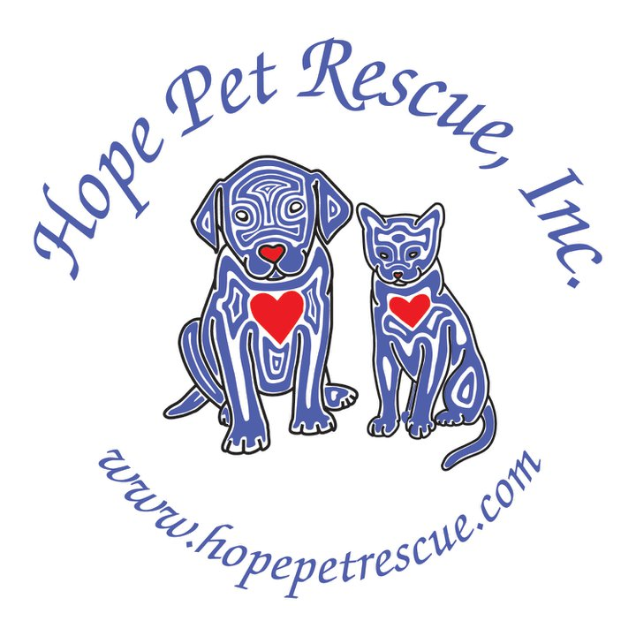
P.O. Box 32, Barrington, IL 60011
- A litter of 10 week old puppies tossed into a 6 ft. snowdrift on the side of the road and left to freeze to death
- A 4 yr. Old Shepherd/Rottie Mix shot by its owner because he “didn't want it anymore”
- 1 yr. Bichon Mix so badly matted you couldn't see her face or touch her because she would cry out in pain

Dear Supporter:

These are just a few of the animals Hope Pet Rescue saved and found homes for in the last year with your assistance. This year, we'll be hosting our 2nd annual Fur Bowlathon fundraiser to be held at Pinstripes in South Barrington on November 4th. As in the past, the success of our event has largely been due to the contributions of our sponsors who have gone out of their way to lend financial support to this event.

As a sponsor, your business is sure to receive exposure from media campaigns and all promotions for the event. You will also gain exposure from the audience attending the event. We have several different packages for sponsorship and these are detailed in the sponsorship commitment form enclosed with this letter. You can choose your level of sponsorship and how you'd like to help save animals' lives and raise awareness in the community.
Established in 2010, we have already saved the lives of over 100 dogs and cats! Every year, the money we raise is donated directly to the care of the animals we save, as well as to educating the public about spaying/neutering their pets, animal welfare, and the concept of “adopting” or “rescuing” new pets rather than “buying”.

Moreover, while there are many organizations fundraising for worthy causes, I hope you will choose Hope Pet Rescue, Inc. and help in our long term vision of building a state of the art, cage less, no-kill animal shelter. As a 501 (c)(3) charitable organization, your donation may be tax deductible.

Thank you in advance for being of invaluable assistance and making a difference in the lives of all the unwanted, abused and neglected animals out there. We look forward to your participation in our exciting upcoming event!

Sincerely,

Mikie Swier
Director of Media/Public Outreach
Hope Pet Rescue
www.hopepetrescue.com

